* Search for IAM in AWS console

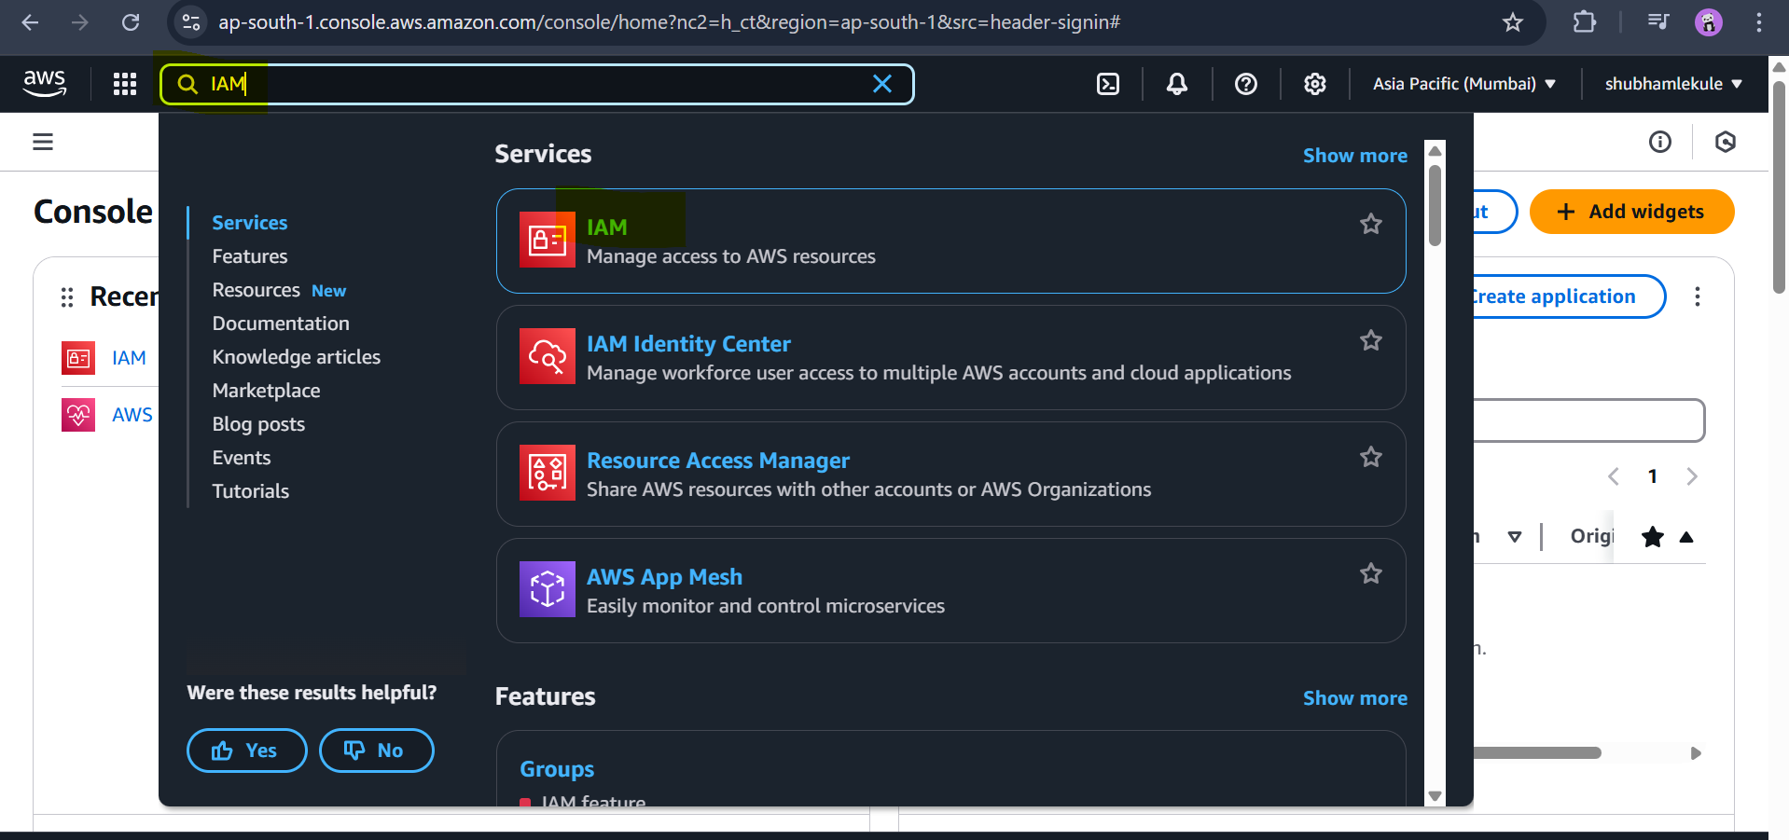

* It will open IAM dashboard

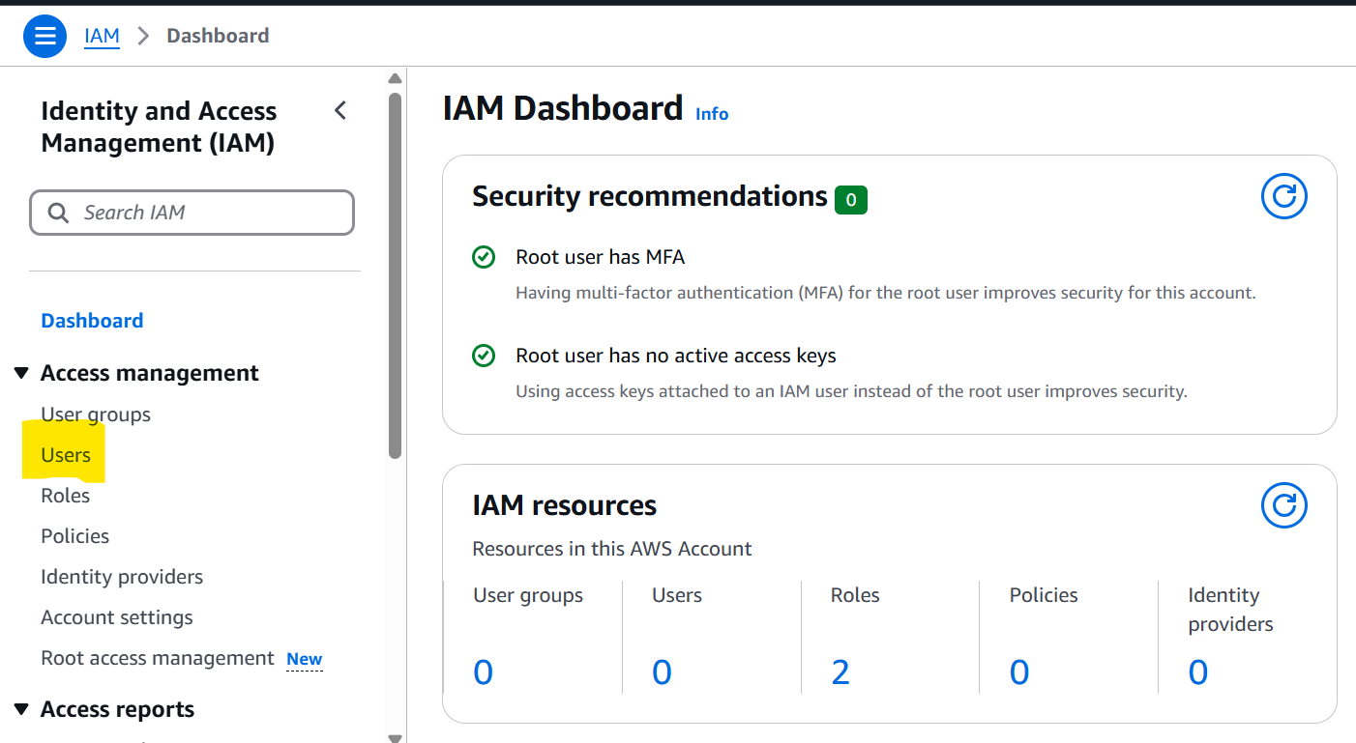

* If we see in top right corner there is global written this means IAM is a global AWS service.

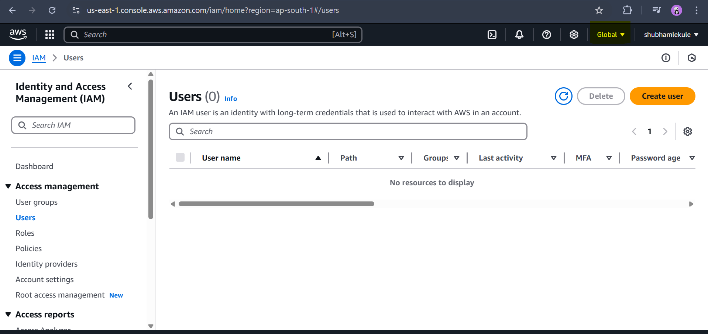

* Its not best practice to use root account if we see in below SS we can see the account number which means we are using root account

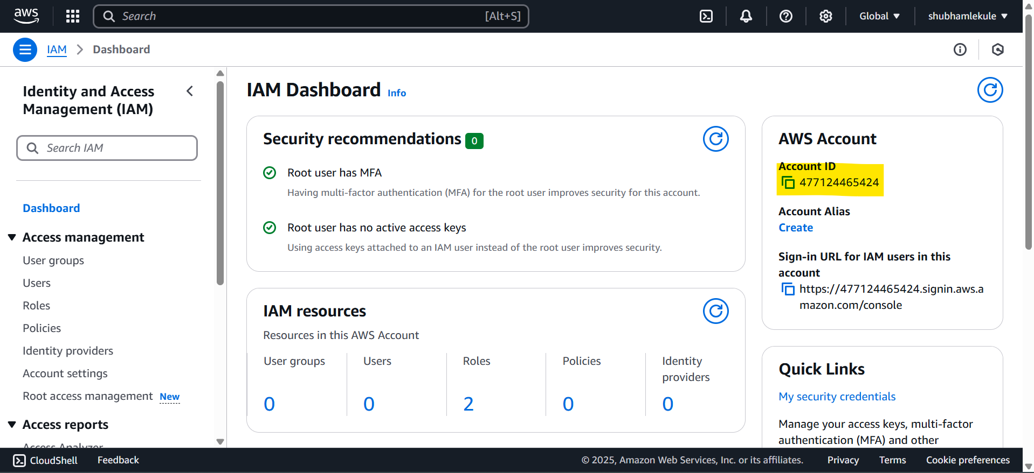

* To Create use click on user:

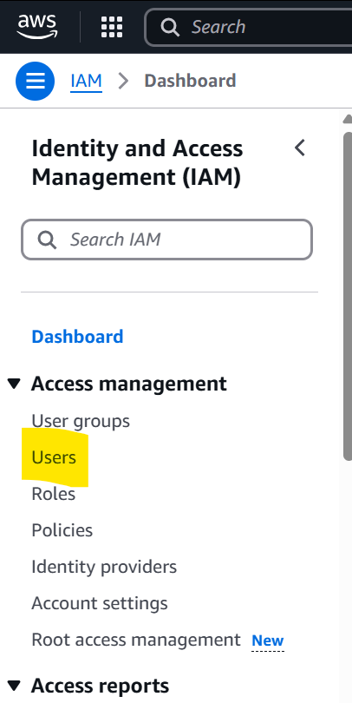

* Click on create users

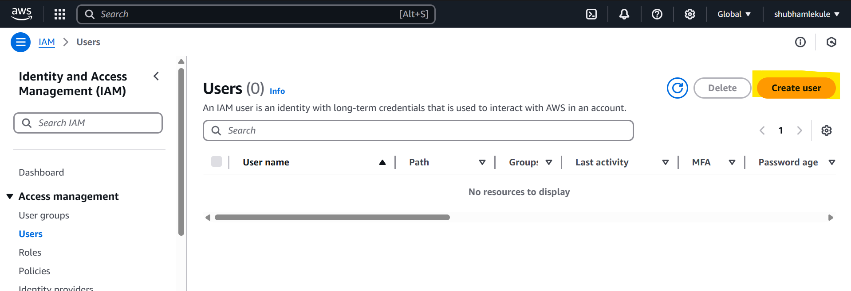

* Enter user name:

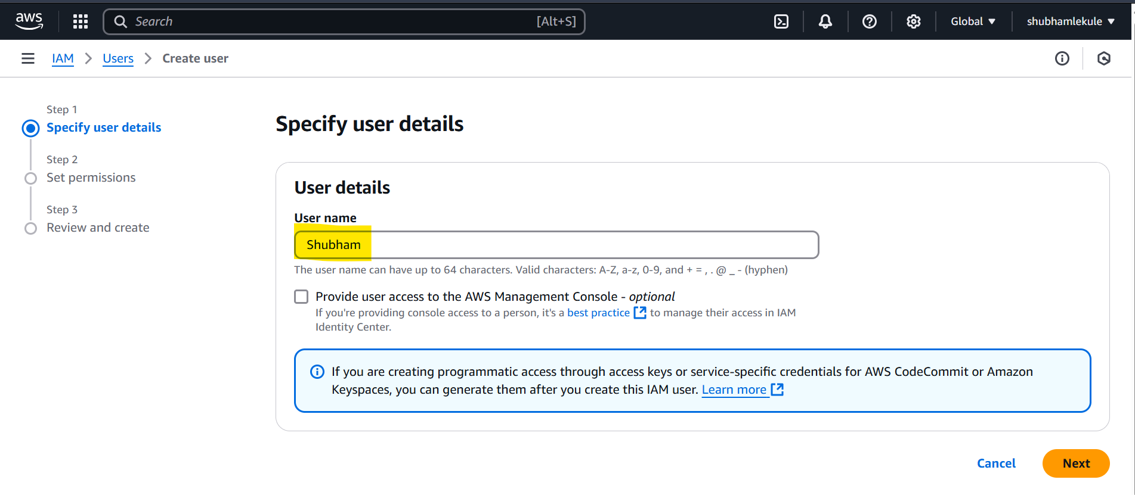

<https://docs.aws.amazon.com/IAM/latest/UserGuide/best-practices.html>

* As I am using this Shubham user as admin user so click on check box for “provide user access to the AWS Management console” and click on radio button for option “I want to create an IAM user”

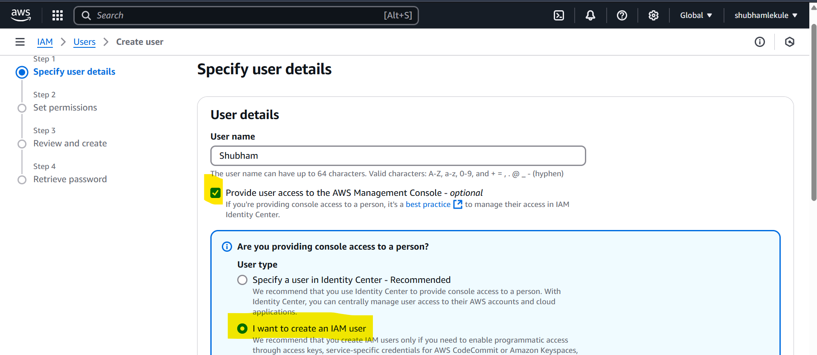

* If you don’t want to auto generate password for your user then click on custom password and if you don’t want to change password after 1st login then untick check box which says “user must create new password at next sign-in Recommended” . As I am admin user I don’t want to change password but if you creating a user for organization its best practice to let that user decide there password by them.

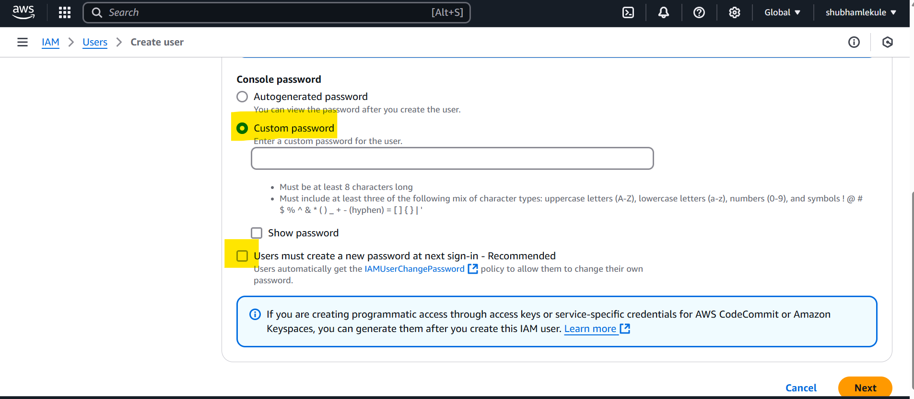

* Once we setup password and click on next we can select group, if its not already there we can create new one, for now there is no group so I am creating new admin group.

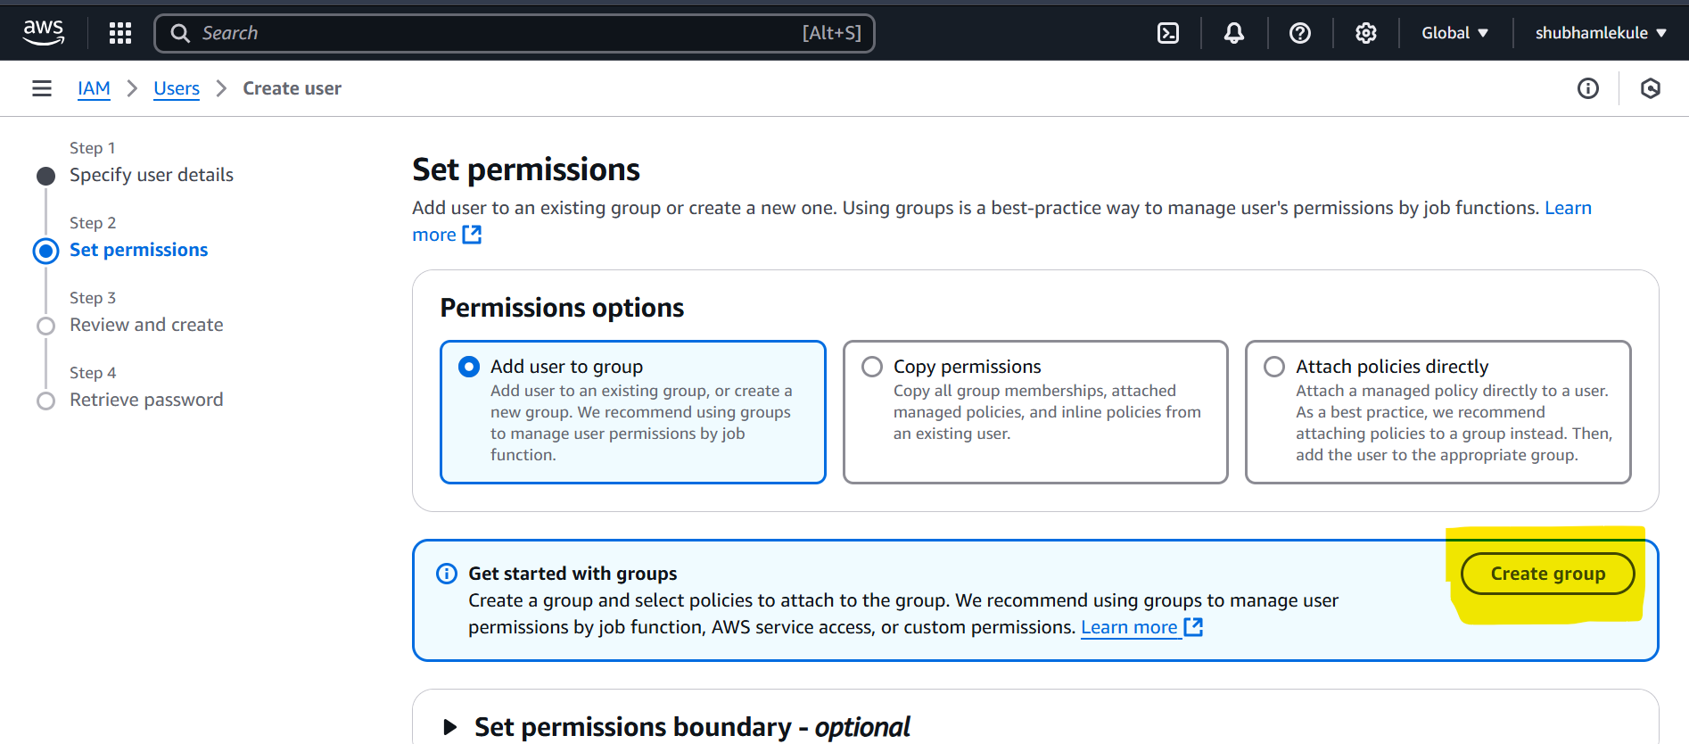

* Once I click on create group I will give group name as Admin group and provide full administrative access to that group then click on create user group button

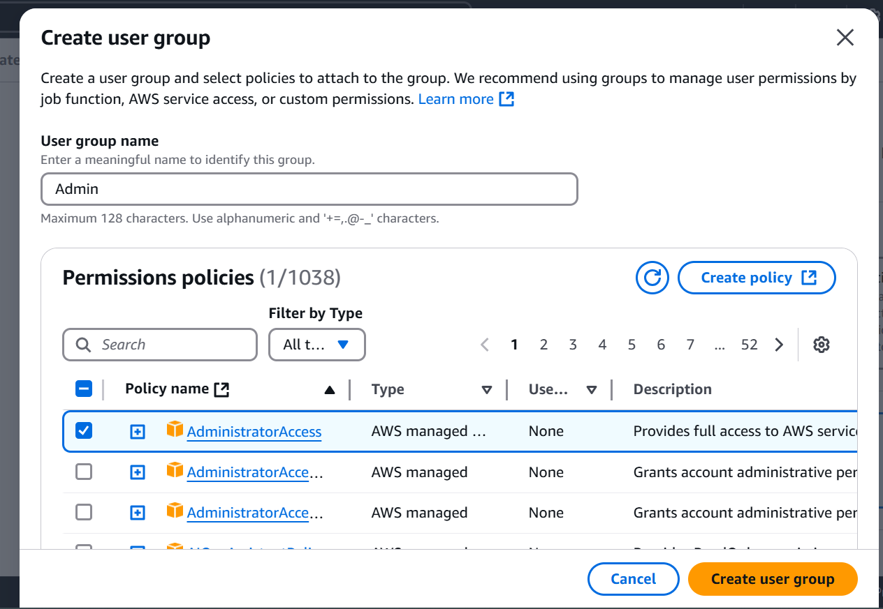

* Once group create select that group for user and click on next

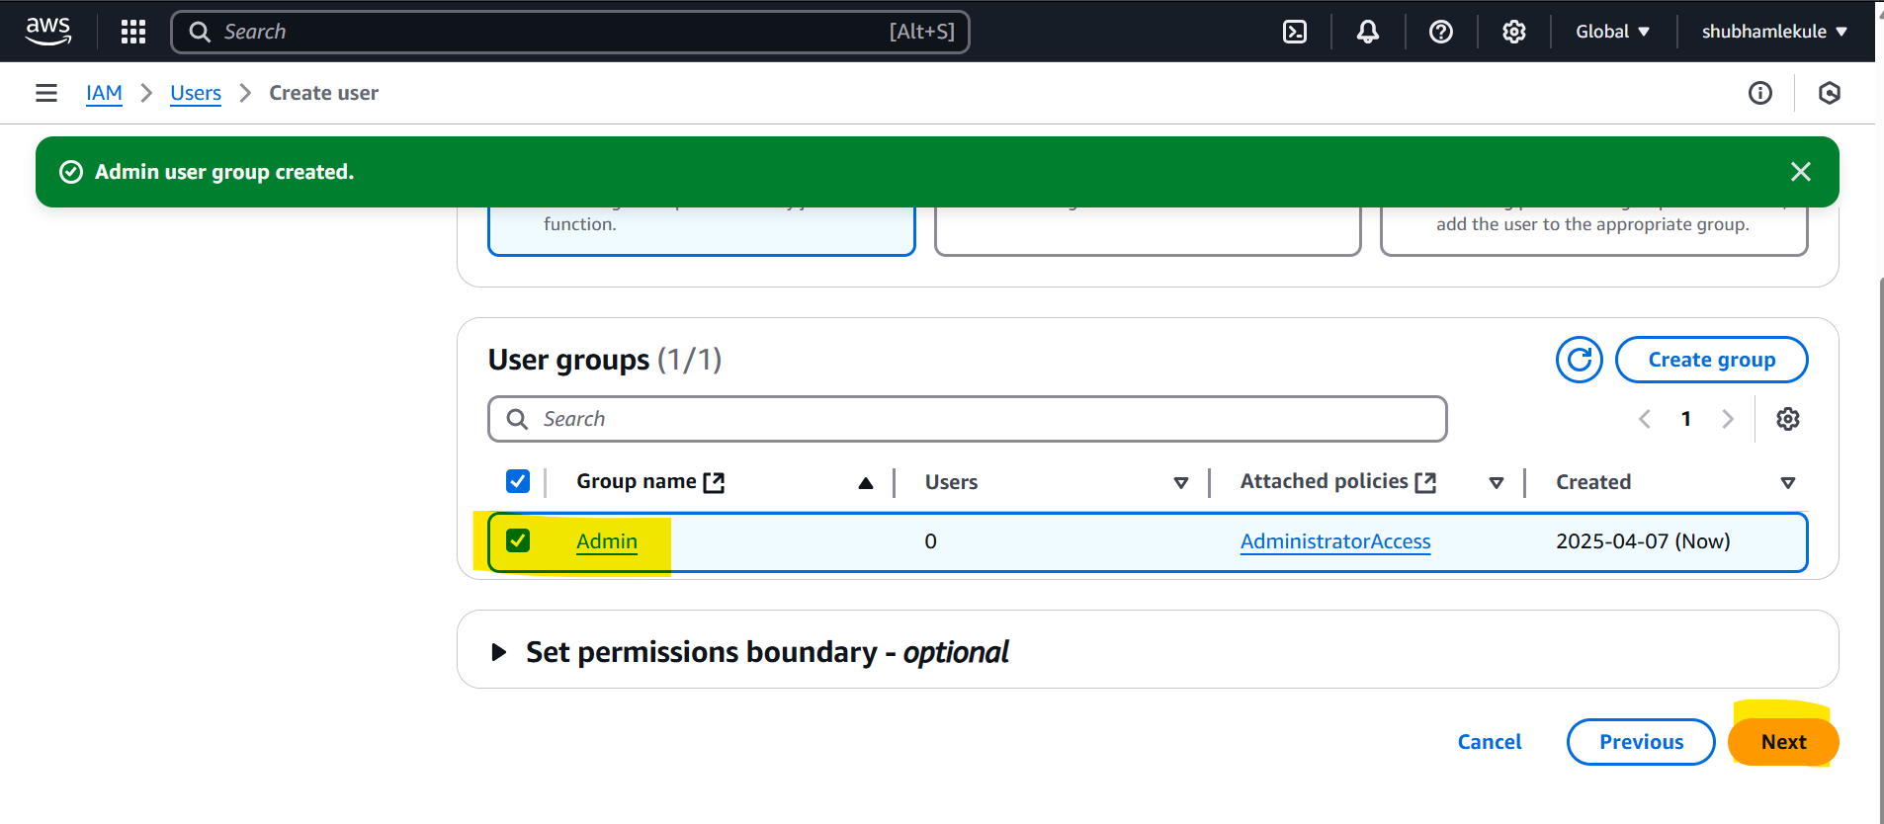

* When click on next you can see all details so far created for user and additionally you can see the Tags option , this is not mandatory but it get used every where to add some meta data or supporting data for service like here we can mention this user belongs to which department or Employee id etc.

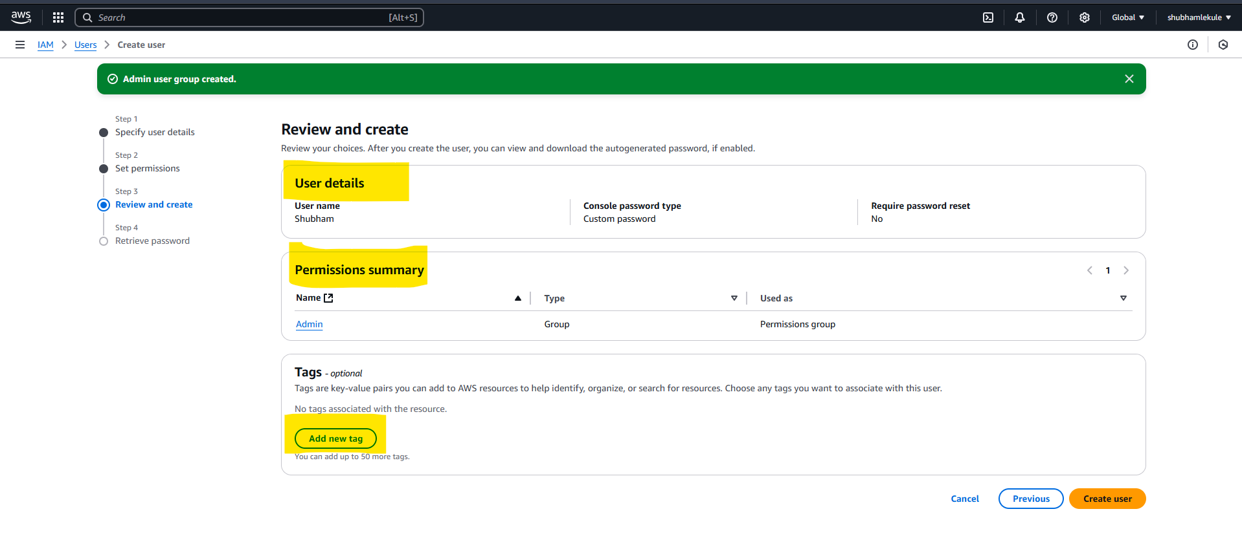

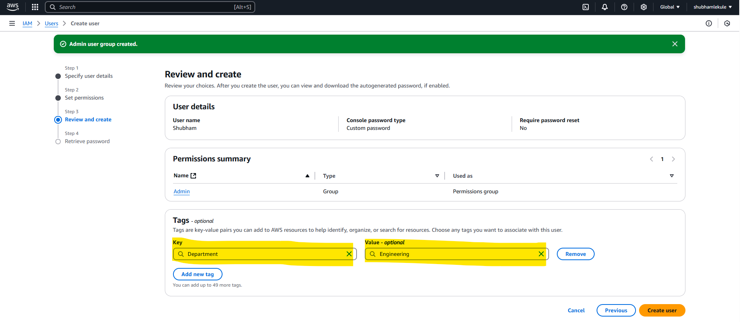

* After that click on create user button, it will create user and we can see there are different option to inform user there credential and access like we can Email sign-in instruction to user or download .csv file and share with user or even provide SS.

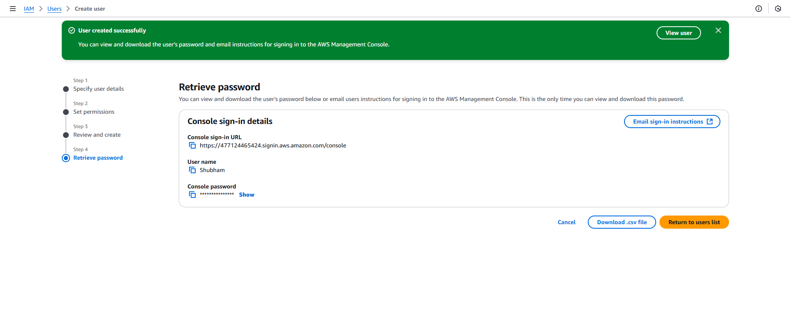

* After creating user we can see created user under Users option

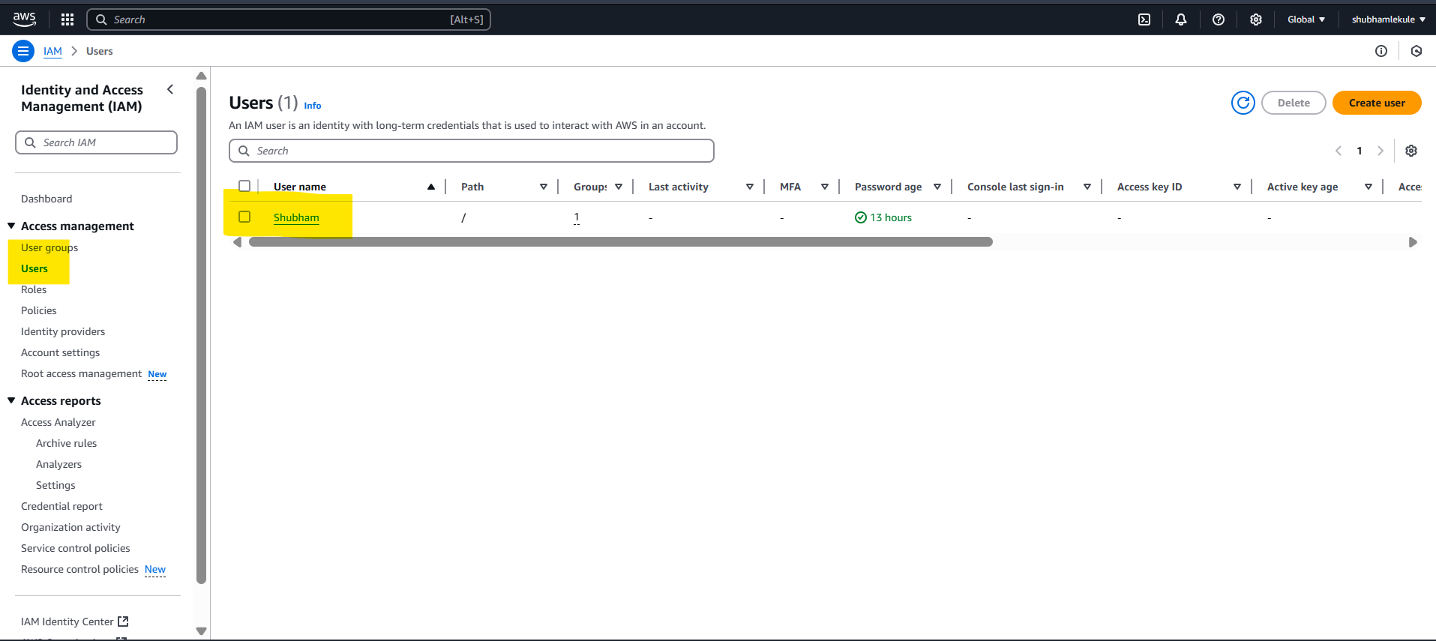

* Also we can see created groups under User groups

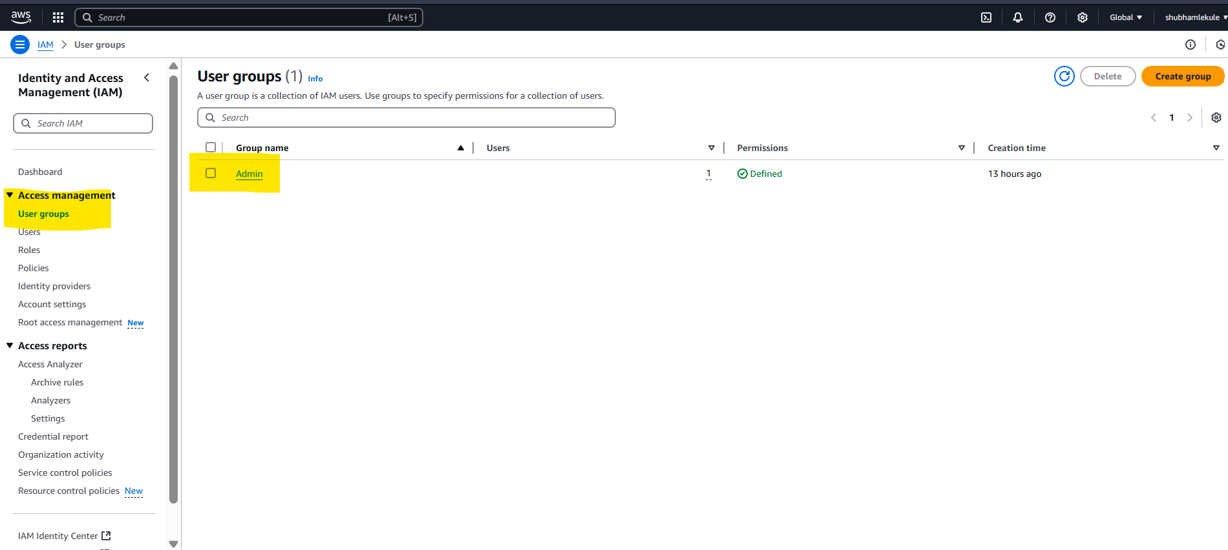

* Once we click on group we can see all details related group like what all user in that group , what all permissions that group have or Last accessed information.

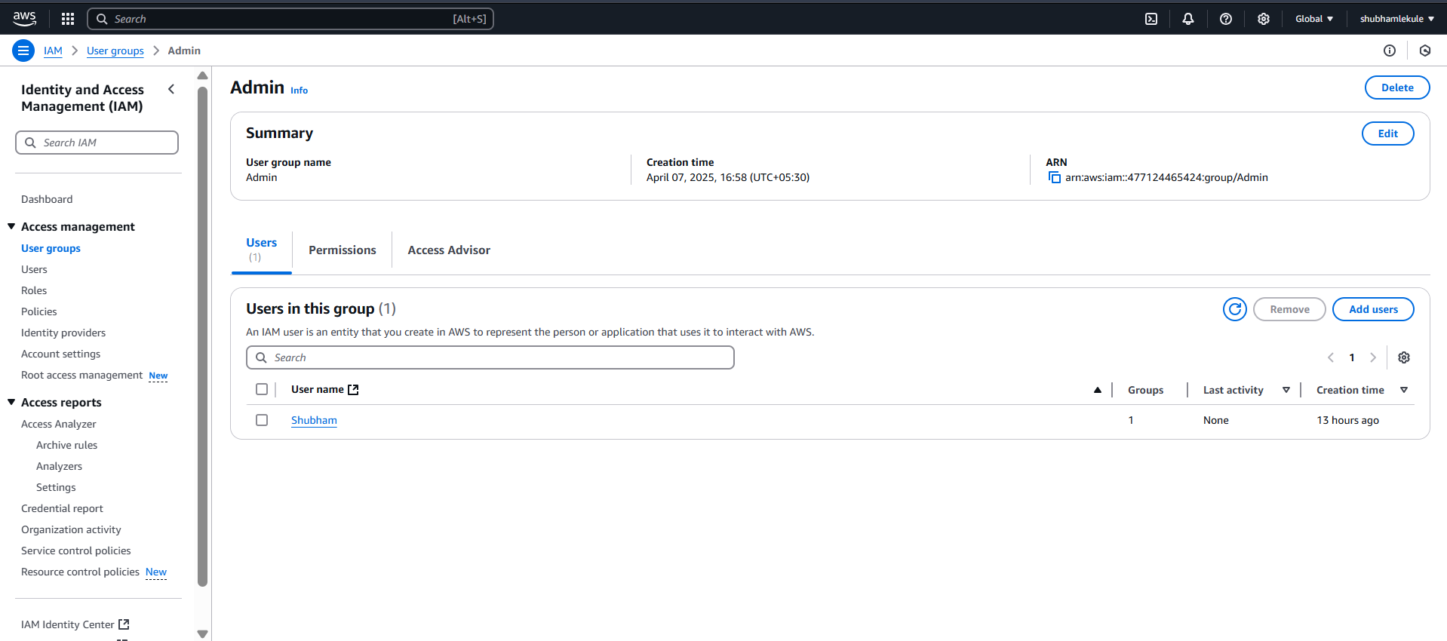

* If we click on user it will show you all user related information like user present in which group or last access information etc.

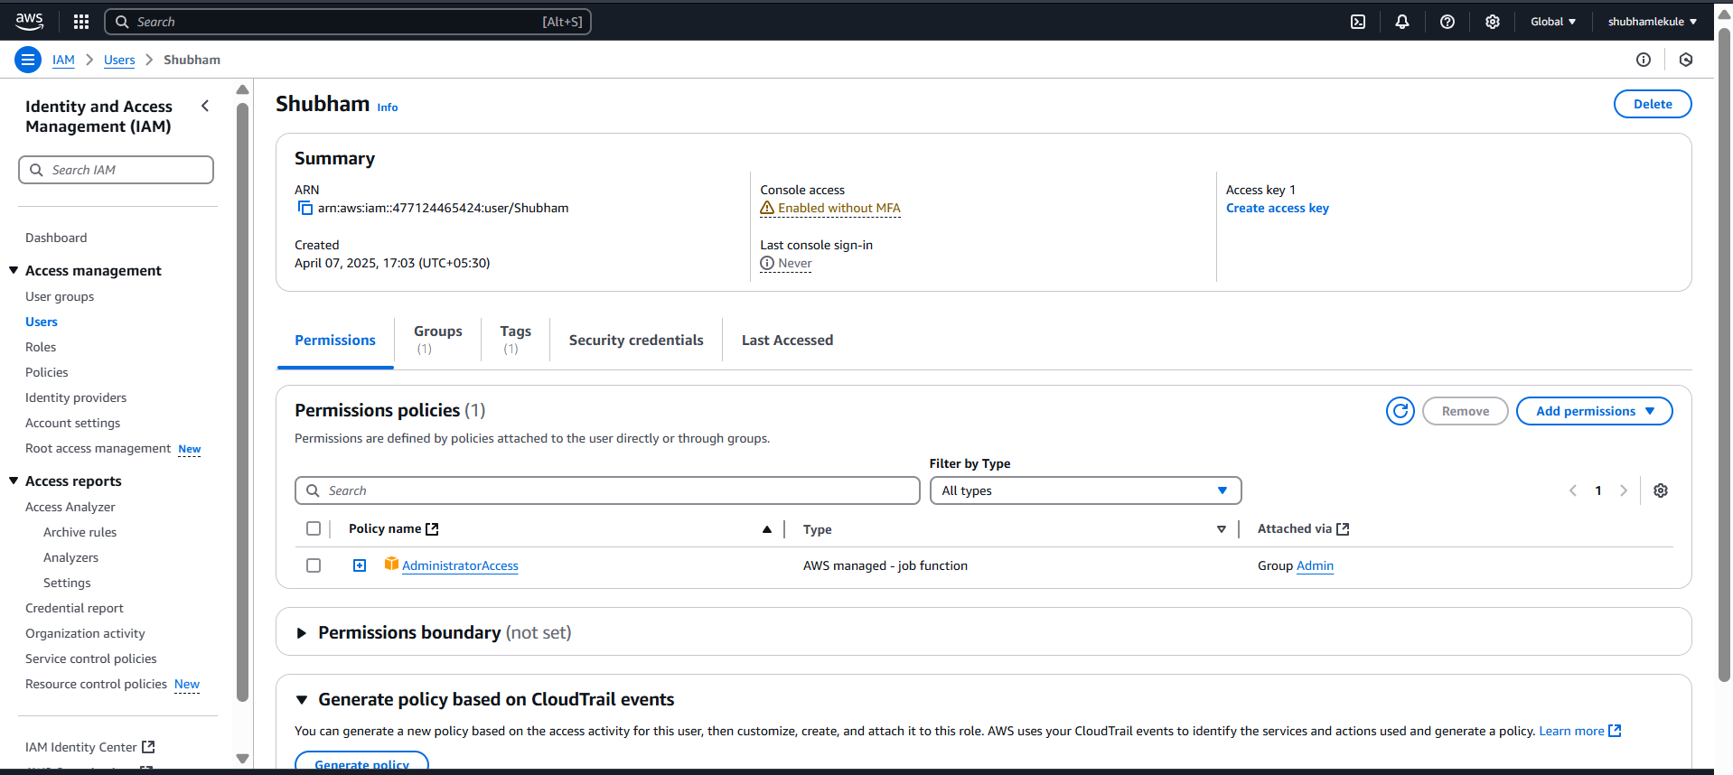

* If we go to dashboard we can see now count of users, groups and roles also we can create alia for this account

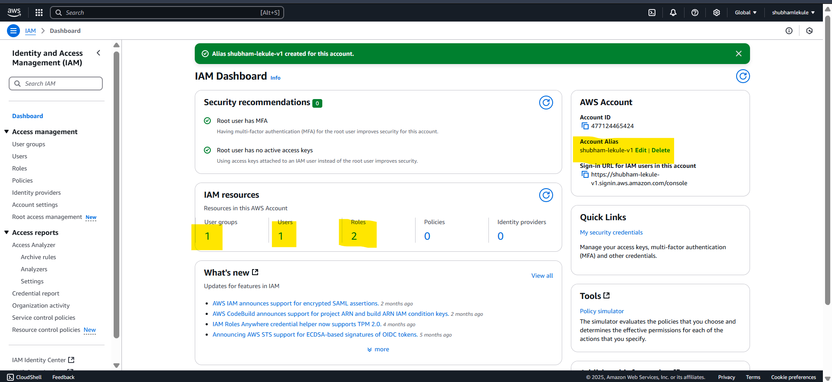

* If we want to update our password go to users -> click on user like here user is Shubham -> click on security credentials -> click on manage console access

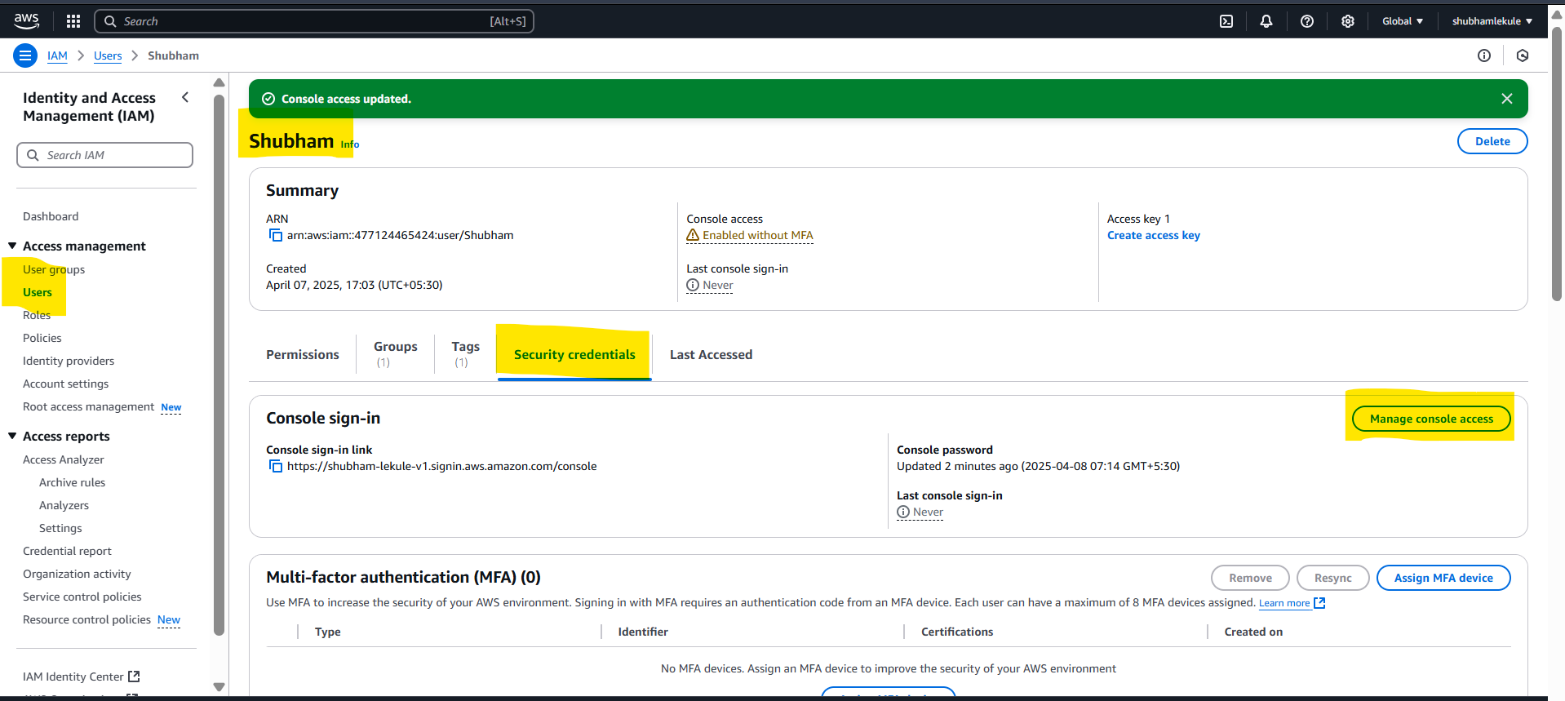

* New pop up will open -> click on reset password -> custom password -> click on Reset Password

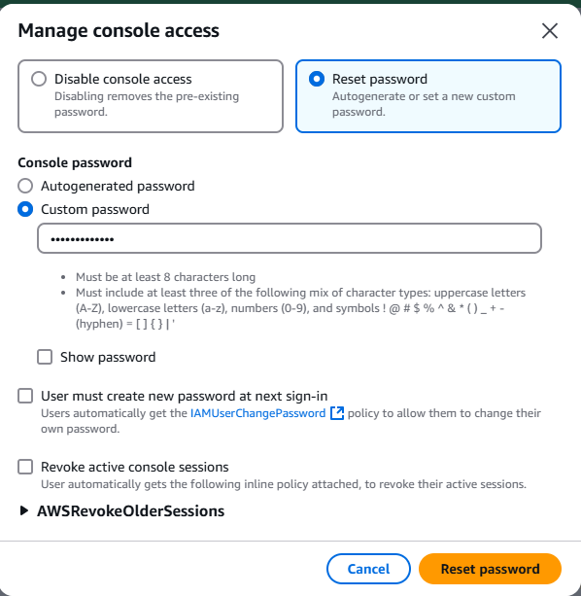

* After creating user we can now login with this new IAM user

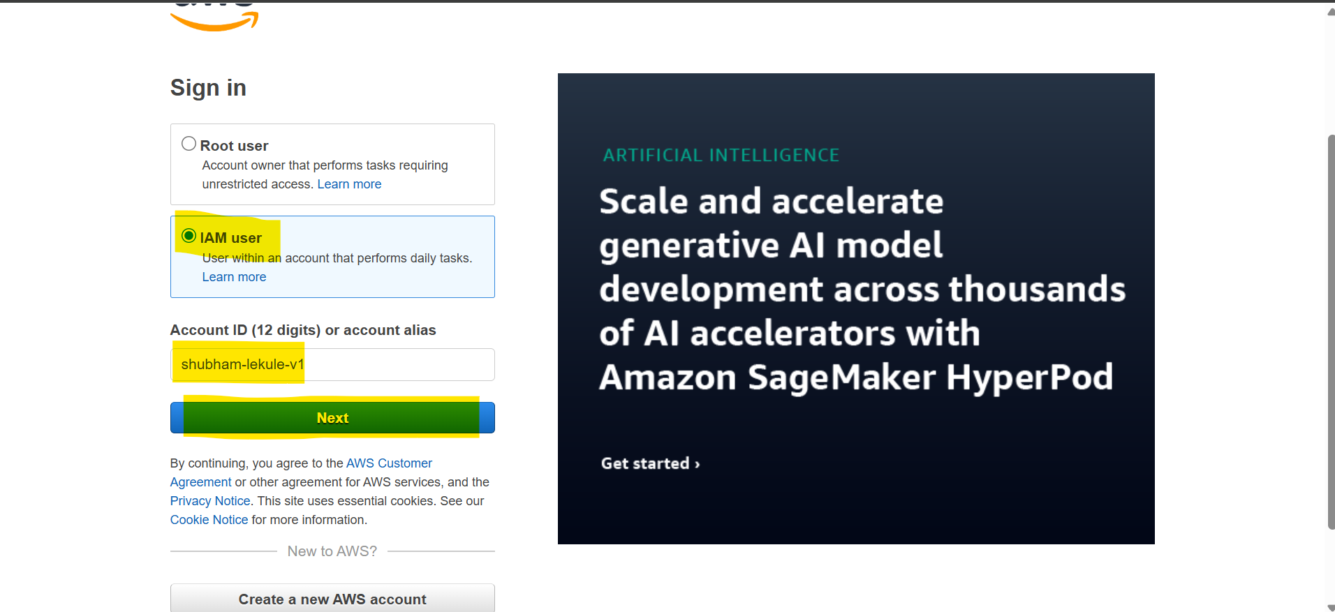

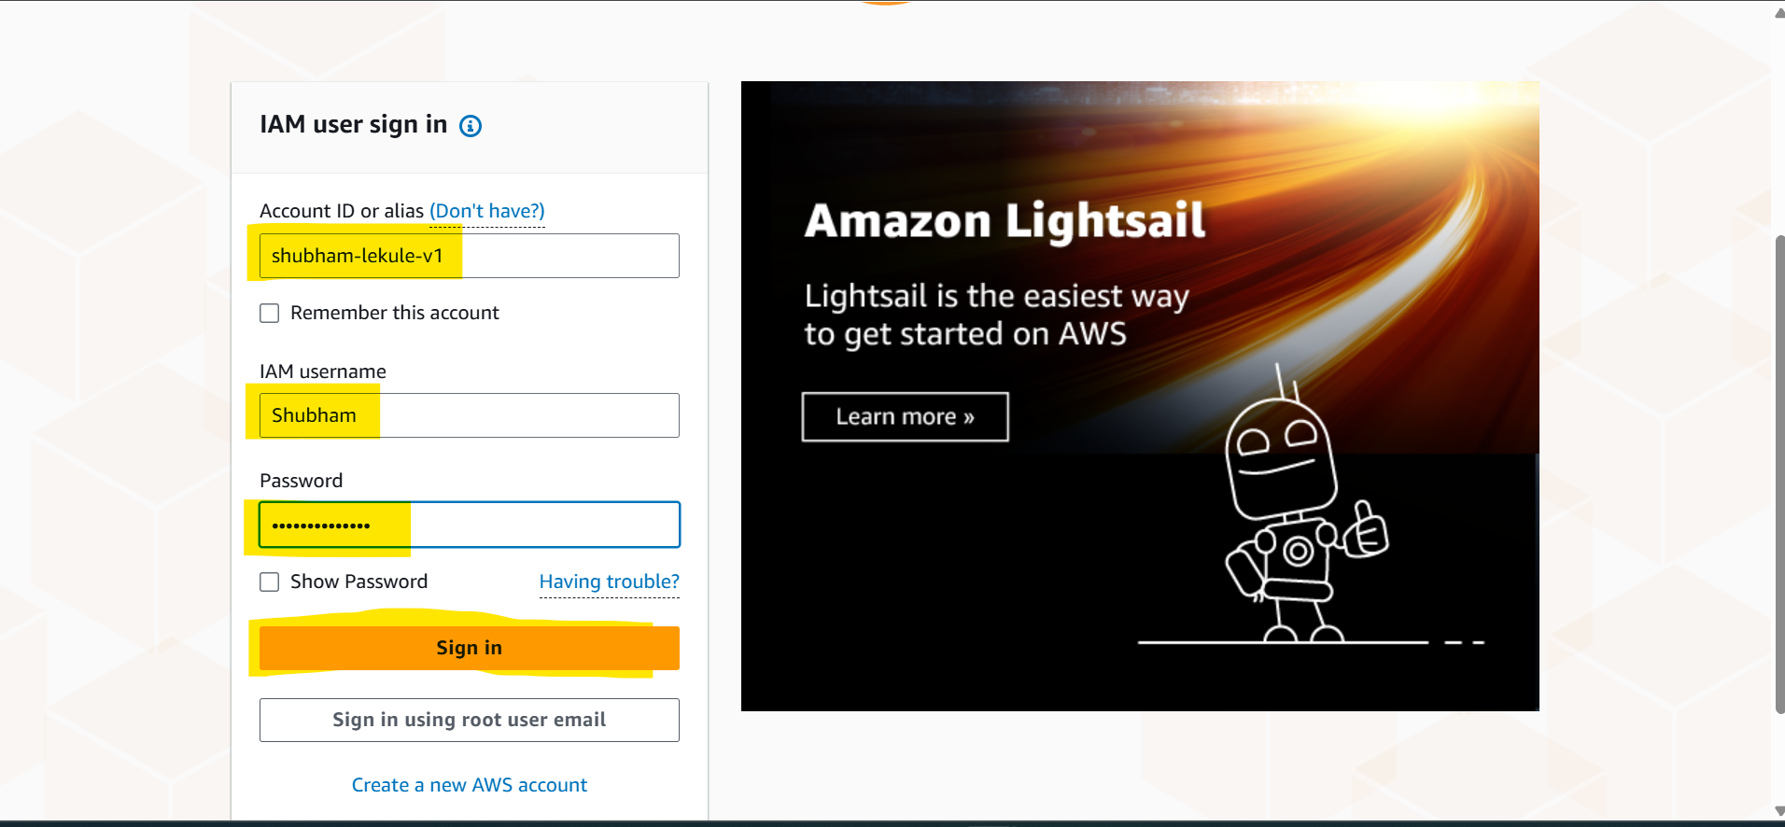

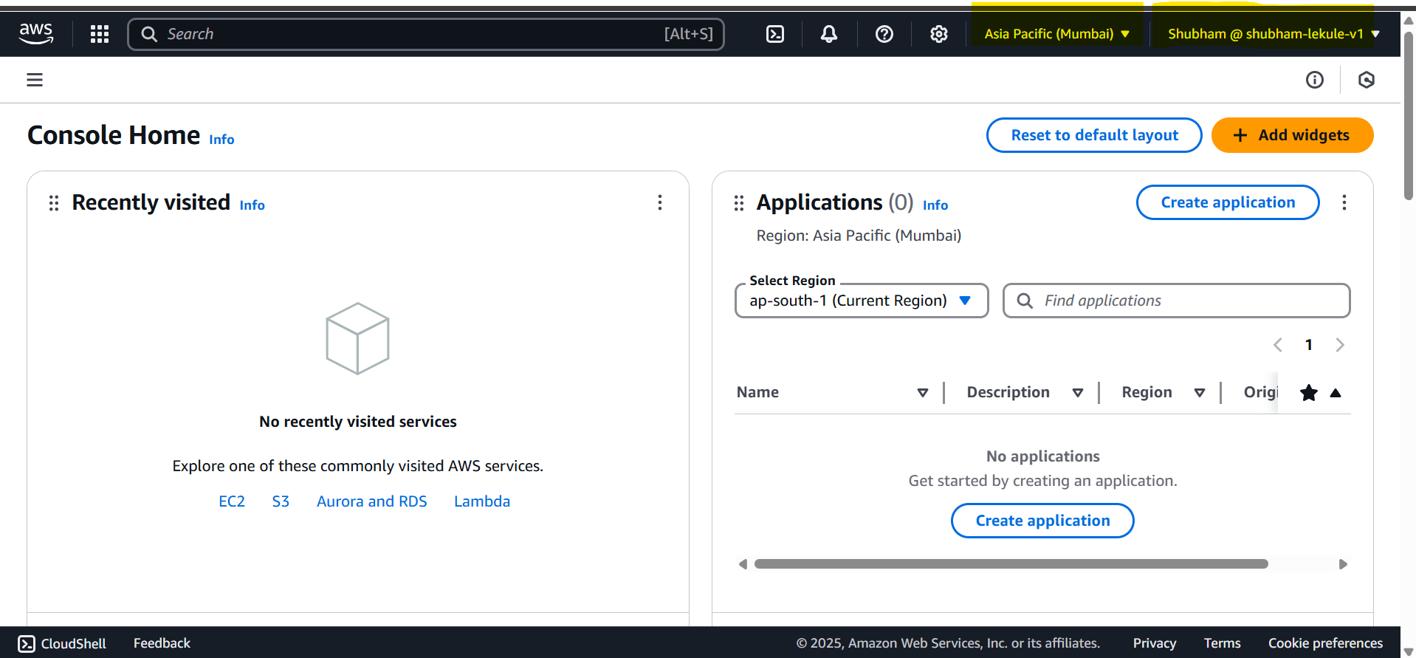

* IAM Policies inheritance